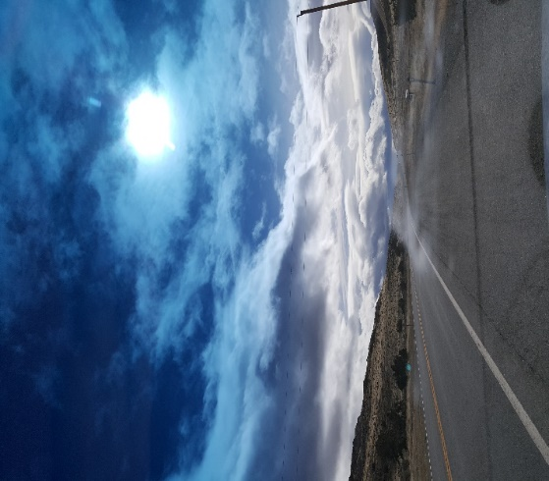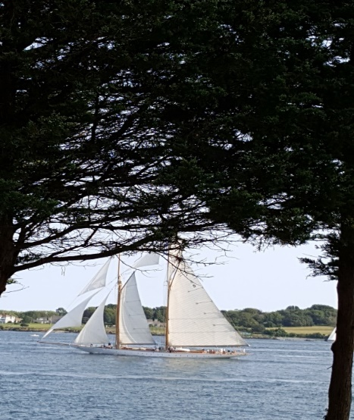
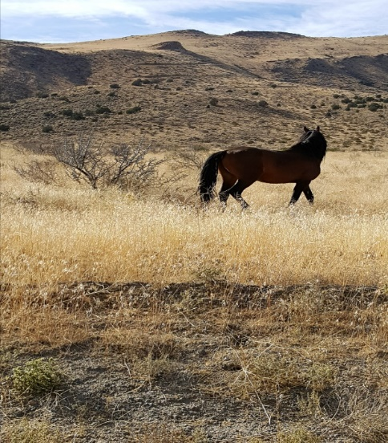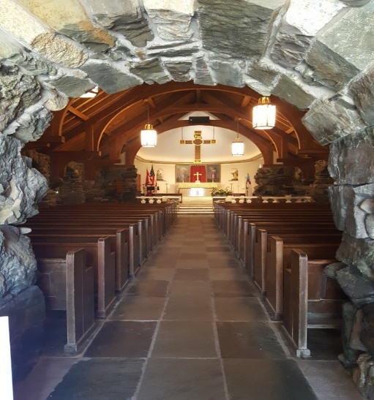
My places of peace are random moments in my life that I was lucky enough
to be able to capture in a photo. Pulling over on the side of the road to
make a phone call, attending a wedding on the coast, driving through the
valley I lived at in Nevada, and walking into St. Annes rock church in
Kennebunkport, Maine.

